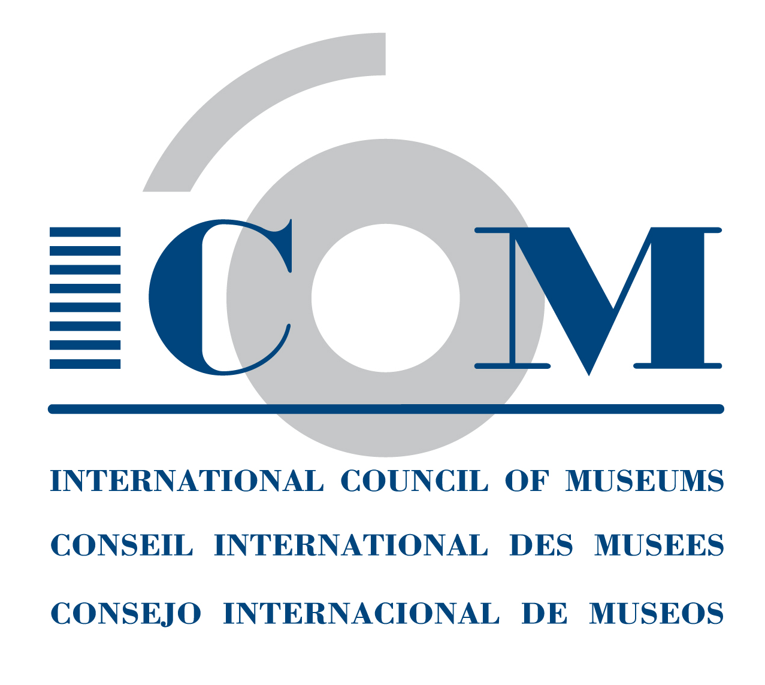 | APPLICATION FORM  INTERNATIONAL COMMITTEE MEMBERSHIP  FOR INVIDIDUAL MEMBERS AND INSTITUTION REPRESENTATIVES  ICOM Secretariat  Maison de l'UNESCO - 1, rue Miollis - 75732 Paris Cedex 15 - France  Tel: + 33 (0) 1 47 34 05 00 Fax: + 33 (0) 1 43 06 05 54  Email: membership@icom.museum Website: http://icom.museum

JOIN THE ICOM INTERNATIONAL COMMITTEES!
With your ICOM individual or institutional membership, you can join ICOM’s International Committees, which represent different types of museum collections and professions.
Institutions can designate up to three of its employees, called designated representatives, to represent them on International Committees. This means that an institution may choose a Committee, and designate three representatives to this Committee. Or, the institution may choose three different International Committees, and designate the same or different representatives to these Committees.
By joining an International Committee:
- You will receive up-to-date news from the International Committee, and have access to their publications and newsletters.
- You may participate in their annual meetings and other activities, with preferential rates.
- You may participate in the discussions among colleagues of the International Committee.
- You can take part in joint activities organised with other ICOM International Committees, ICOM National Committees and other organisations.
- You can join the special interest or working groups of some International Committees.

INDIVIDUAL MEMBERS AND INSTITUTION DESIGNATED REPRESENTATIVES
If you have not yet joined any International Committee or if you wish to change your International Committee, please choose:
- one (1) in which you have voting rights (except Student and Supporting members):
- up to three (3) in which you are interested in order to receive information from them:

Archaeology & History (ICMAH)
Architecture & Museum Techniques (ICAMT)
Arms & Military History (ICOMAM)
Audio-visual & New Technologies (AVICOM)
Conservation (ICOM-CC)
Decorative Arts and Design (ICDAD)
Collecting (COMCOL)
COSTUME
Documentation (CIDOC)
Education & Cultural Action (CECA)
Egyptology (CIPEG)
Ethnography (ICME)
Exhibition Exchange (ICEE)
Fine Arts (ICFA)
GLASS
Historic House Museums (DEMHIST)
Literary Museums (ICLM)
Management (INTERCOM)
Marketing & Public Relations (MPR)
Memorial Museums (IC MEMO)
Money & Banking Museums (ICOMON)
Museology (ICOFOM)
Museum Security (ICMS)
Museums of Cities (CAMOC)
Musical Instruments (CIMCIM)
Natural History (NATHIST)
Regional Museums (ICR)
Science & Technology (CIMUSET)
Training of Personnel (ICTOP)
University Museums (UMAC)

For more information on the ICOM International Committees, please see http://icom.museum/the-committees/international-committees.

First Name: | Last Name:
ICOM Individual or Institution card number:
E-mail:  Date: | Signature:

Note: The above information will be automatically processed to ensure your receipt of services from ICOM. In conformity with the French law on Informatics & Civil Liberties (Jan. 6, 1978, rev.) you have the right of access and to modify the information that concerns you.

October 2014

